**OPERATING SYSTEMS LAB**



Session: 2022 – 2026

**Assignment: Window Downloading Manual**

**Submitted By:**

Irtaza Manzoor 2022-CS-189

**Submitted To:**

DR. NUMAN SHAFI

**Department of Computer Science**

**University of Engineering and Technology**

**Lahore Pakistan**

**Objective:**

In this lab we will learn about the window downloading. After follow the given steps you will be able to download window in your device and there will be no need to go to the Hafeez center and to the Seniors to get help about this. So follow these steps.

**Step 1:**

First of all go the Google and search VMware and download it by clicking on the first link.

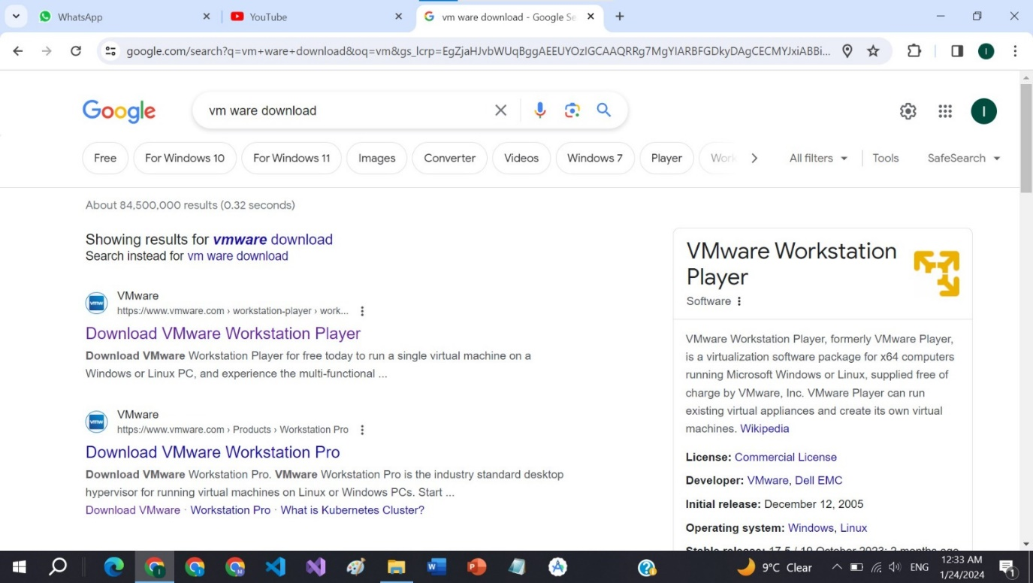

**Step 2:**

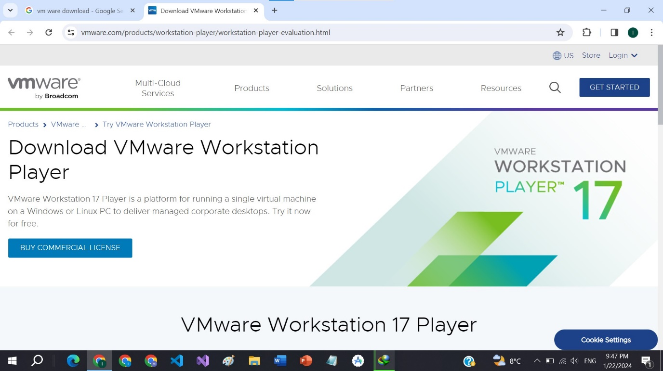 Click on the **GET STARTED** and then continue.

**Step 3:**

Click on the **TRY WORKSTATION 17 PLAYER FOR WINDOWS.**

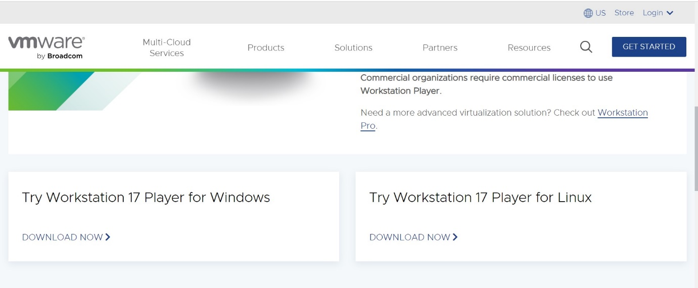

**Step 4:**

Click on the **Create a New Virtual Machine**

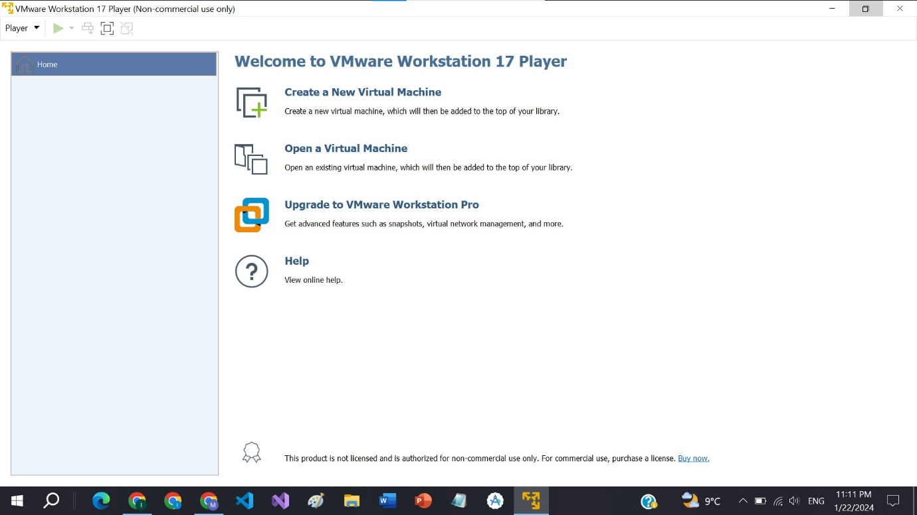

**Step 5:**

Browse your **ISO file** from your system and **click on Next**

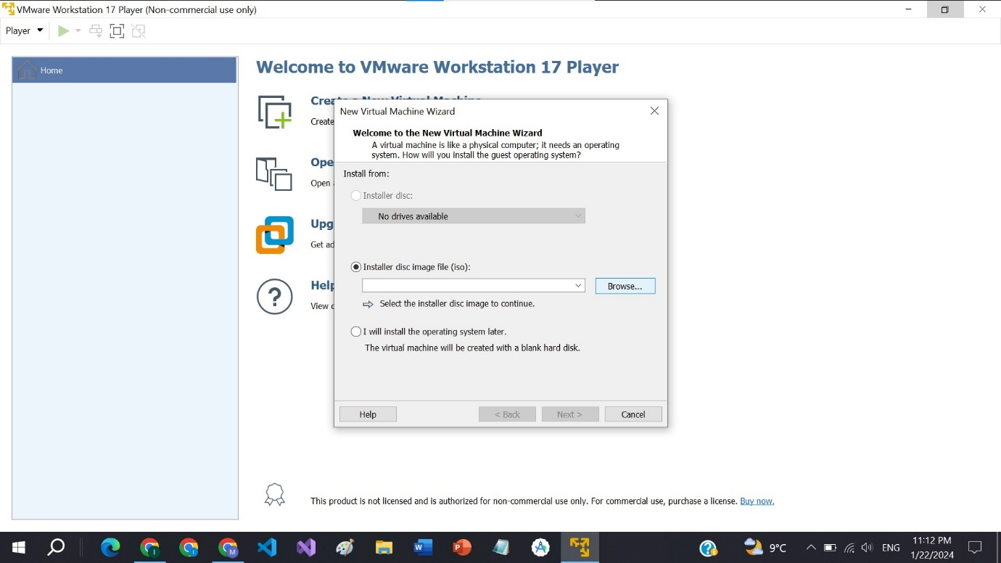

**Step 6:**

**Create Password** for VMWare.

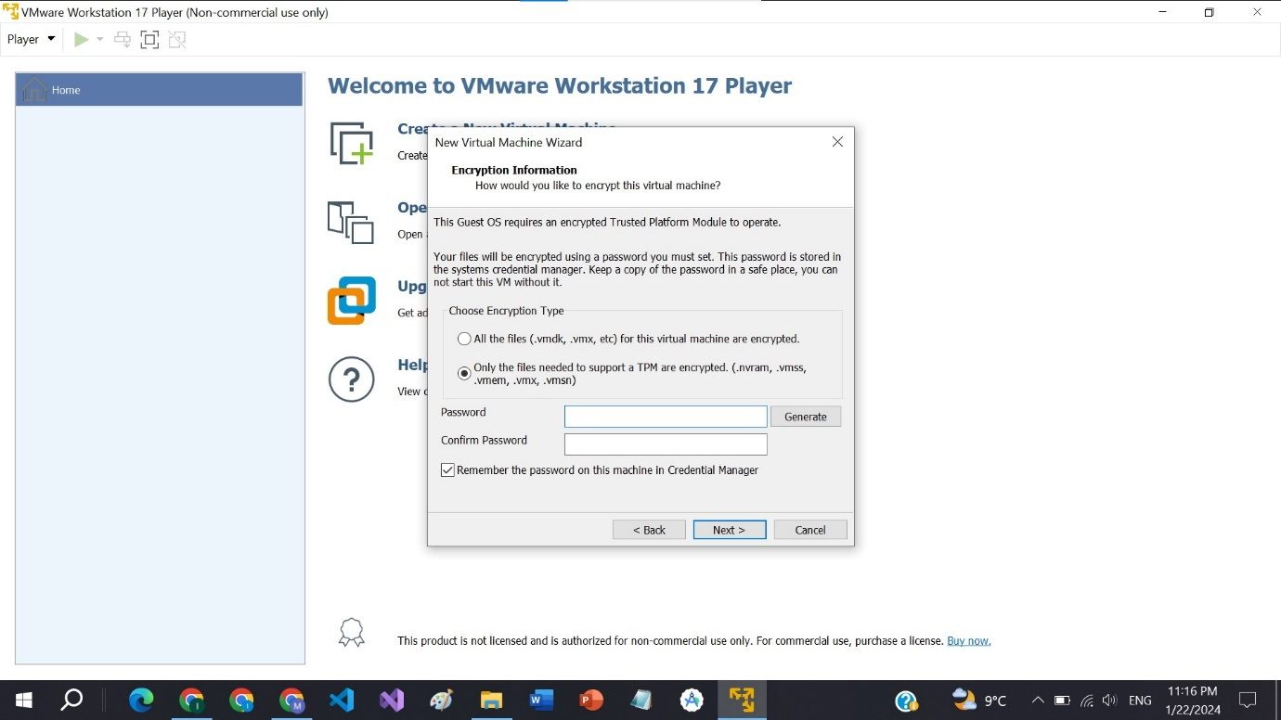

**Step 7:**

Select **storage for Windows 11** which is minimum of 50GB.

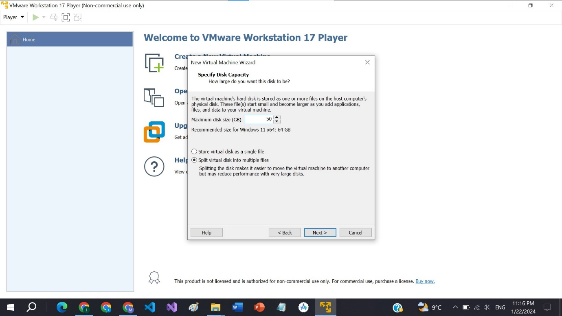

**Step 8:**

Then **click on Customize Hardware** to allocate RAM and Memory.

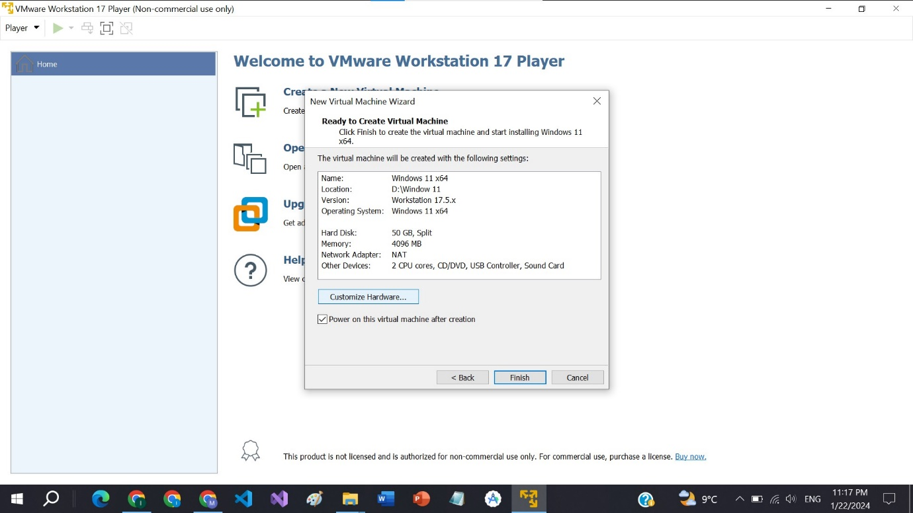

**Step 9:**

Make sure that **minimum of 4GB Memory** is allocated if not then allocate 4GB RAM to it. You can increase this also depending on your system specifications.

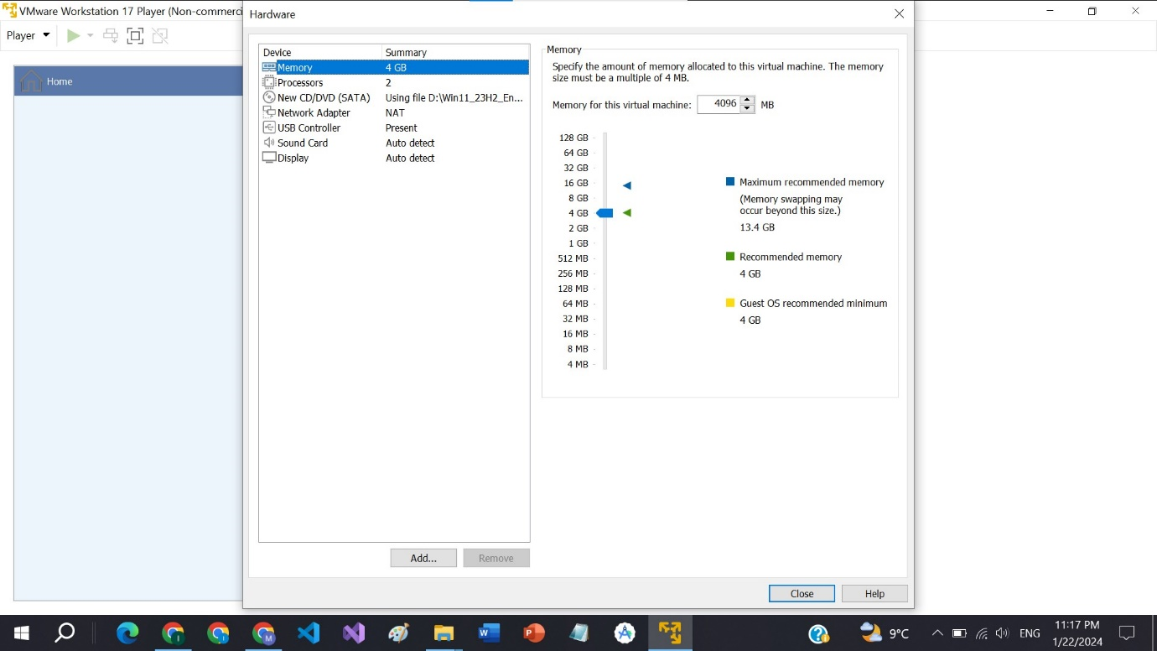

**Step 10:**

After this, now **select your default language** and click Next.

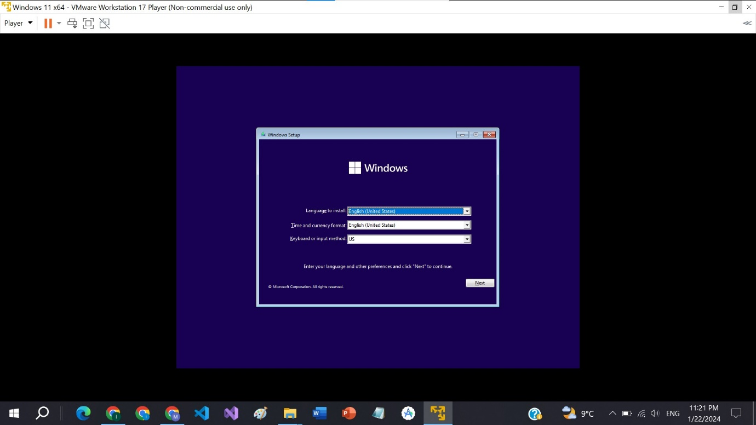

**Step 11:**

Click on **Install Now.**

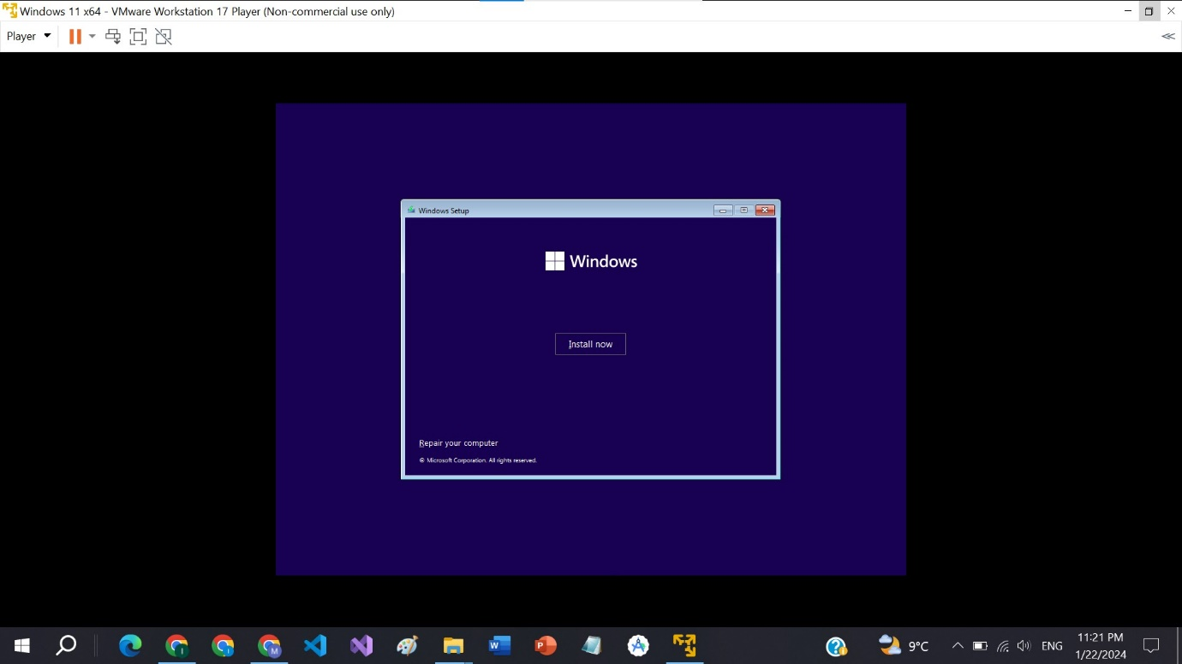

**Step 12:**

Select **Windows 11 Pro.**

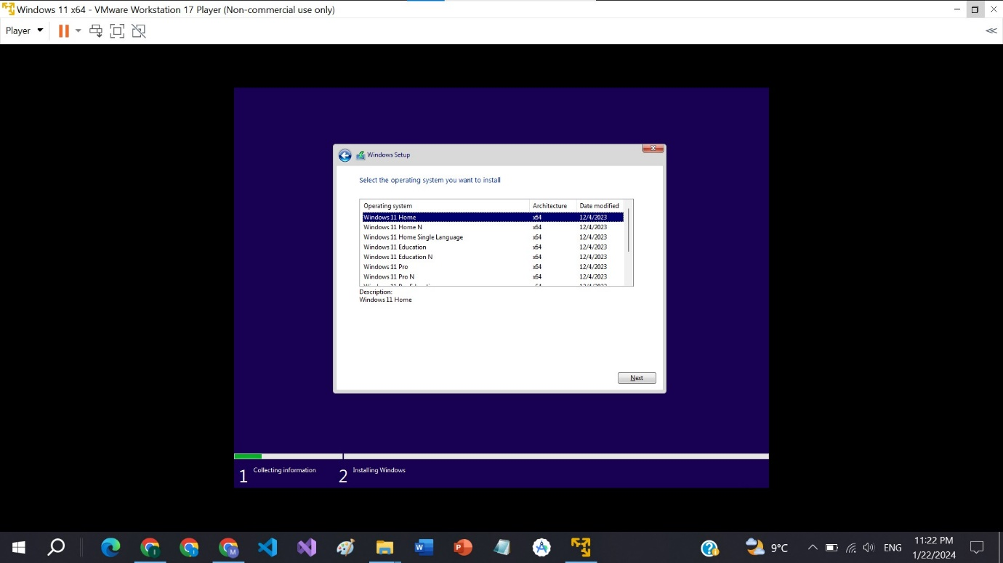

**Step 13:**

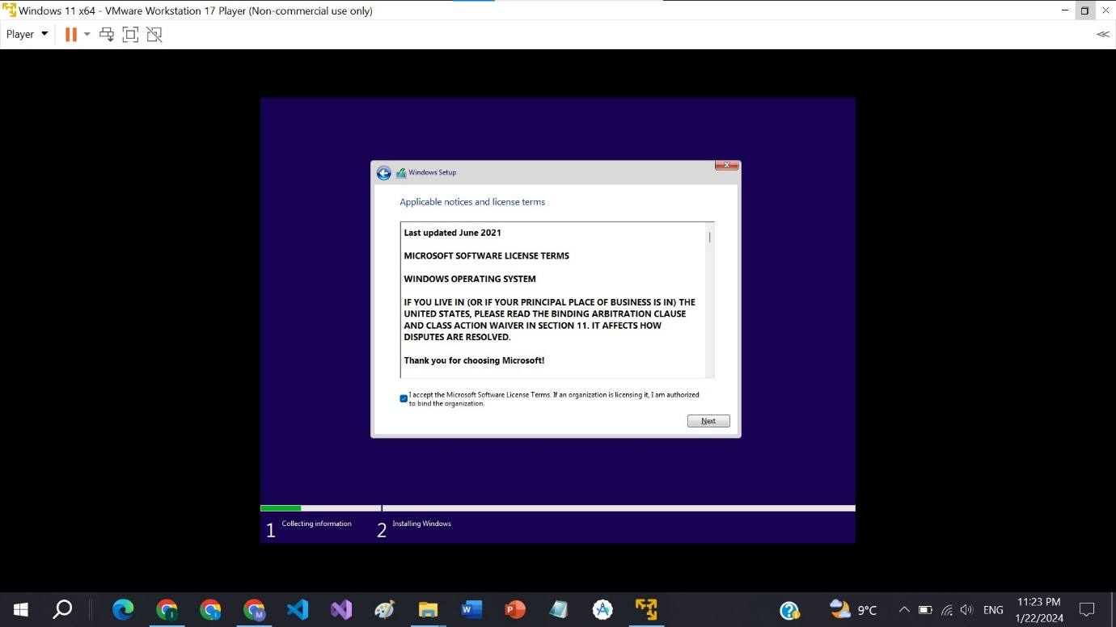

**Step 14:**

Click on **Install Windows Only.**

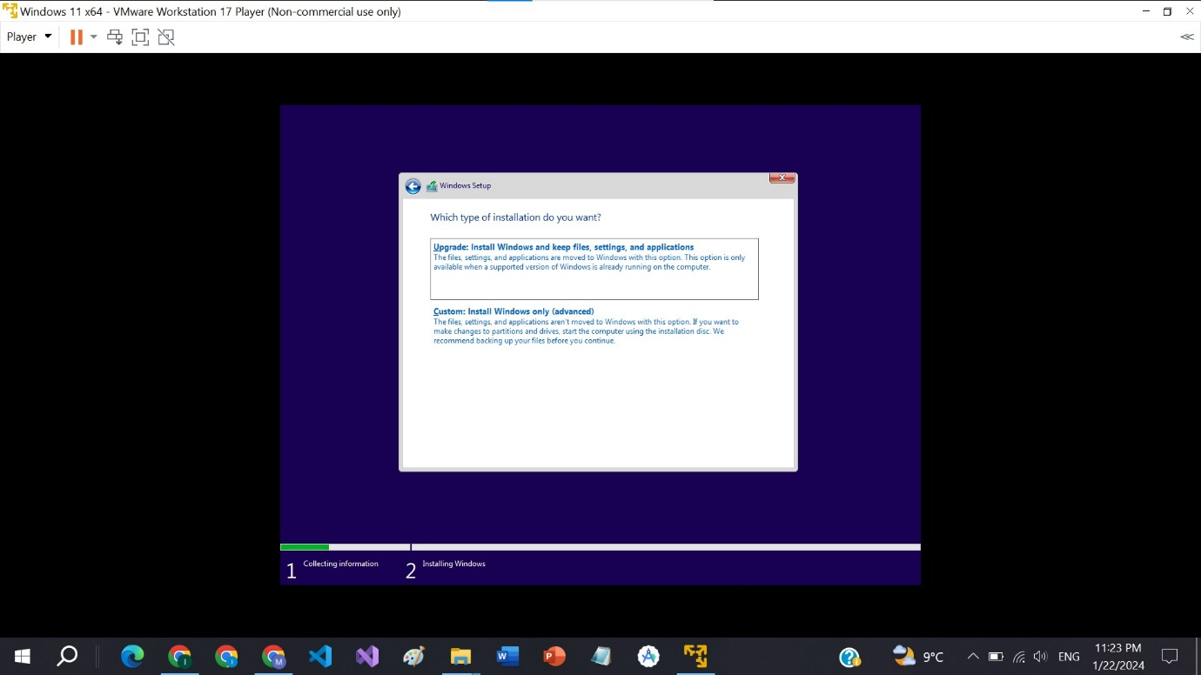

**Step 15:**

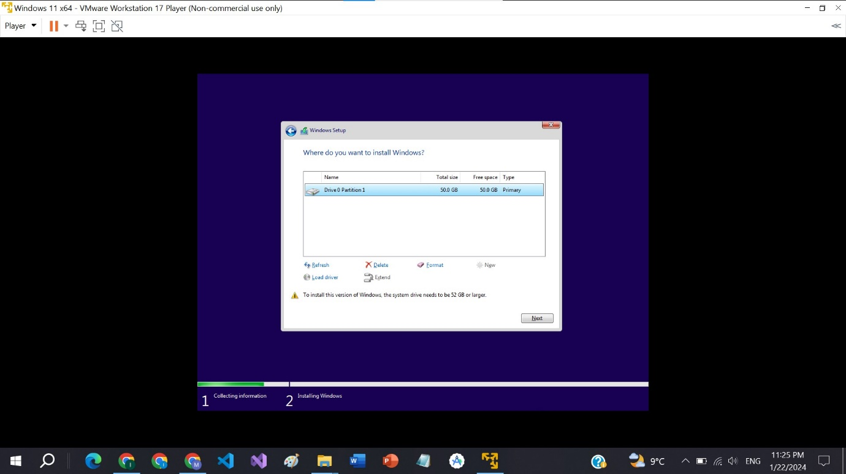

**Step 16:**

Your windows is installing now.

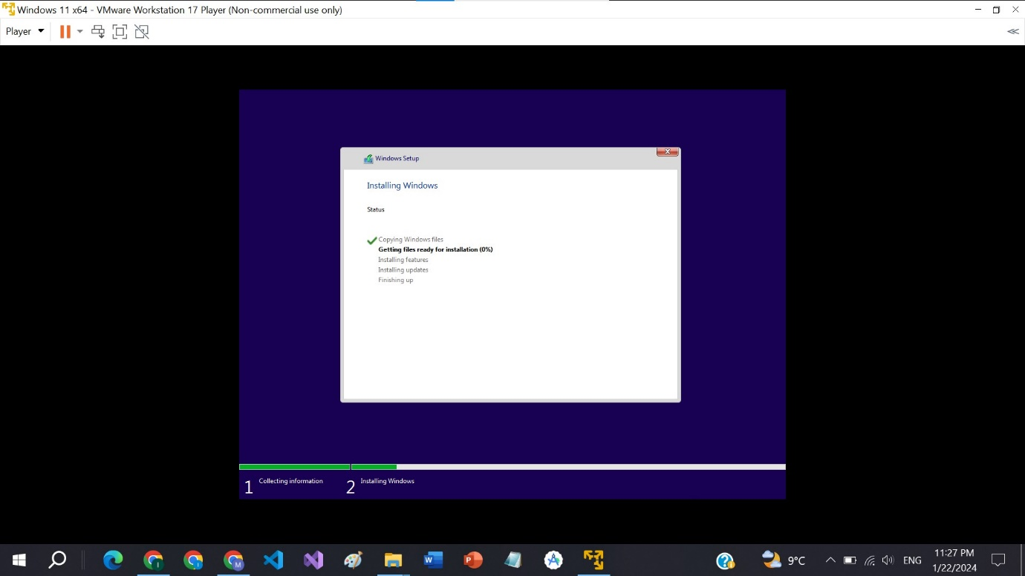

**Step 17:**

Congratulations, you have installed Windows 11 on your system.

